PREVERJANJE ZNANJA
angleščina – 4. razred

- Povej po angleško:
- Moj najljubši obrok je zajtrk. ______________________________
_____________________________________________________
- Imam veliko rumeno žogo. _________________________________
_____________________________________________________
- Nimam majhnega vijoličnega tovornjaka. ______________________
_____________________________________________________
- Rad imam piškote in sladoled. _______________________________
_____________________________________________________
- Ne maram brokolijeve juhe. ________________________________
_____________________________________________________

- Dopolni:
_______ sixteen 12 ______________________
_______ eleven 14 ______________________
_______ seventeen 15 ______________________
_______ nineteen 18 ______________________
_______ thirteen 20 ______________________

- Zapiši po angleško:
hruška __________ čokolada ________________ testenine __________
torta _______________ gobe ______________ paprika ____________
krompir ____________ sir ________________ kruh _____________
jabolko _____________ kosmiči ____________ piščanec ___________
mleko ______________ shramba _______________ stena ________
postelja _____________ pisalna miza __________ preproga ______
garderobna omara ________________ omara za knjige _______________
stol _____________ slika _______________ naslonjač __________
kad _____________ tuš _____________ ogledalo________________
hladilnik ________________ štedilnik ____________________
spalnica __________________ kopalnica _______________________
kuhinja ____________________ garaža __________________________
dnevna soba ____________________ vrt ______________________

- Vstavi A ali AN, nato pa besedam zapiši množinsko obliko:
____________ banana ___________________________
____________ elephant ___________________________
___________ egg ___________________________
___________ car ___________________________
___________ bike ___________________________
__________ ear ___________________________

- Opiši sliko. Uporabi THERE IS in THERE ARE. Spodnje besede so za v pomoč. Uporabi čim več različnih krajevnih predlogov (in, on under, between, next to…)
mirror chair bookcase rug lamp painting book wardrobe
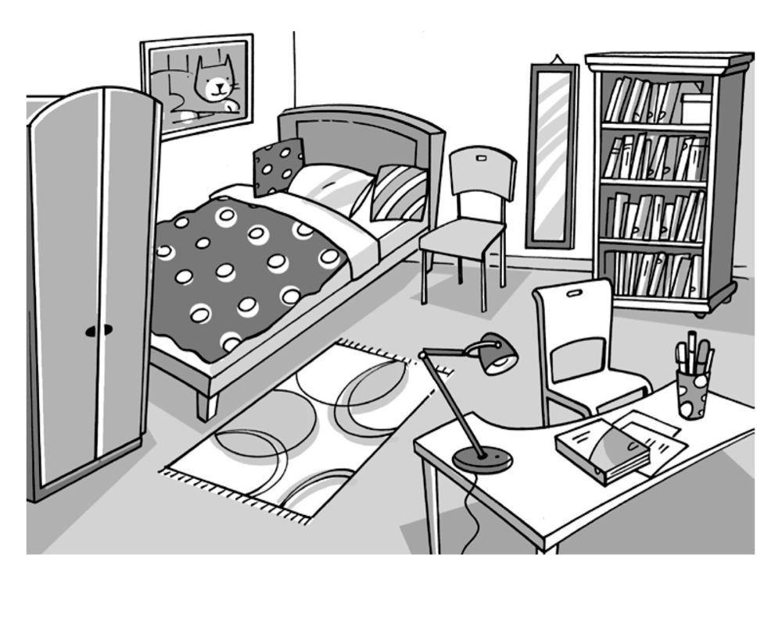
__________________________________________________________________________________________________________________________________________________________________________________________________________________________________________________________________________________________________________________________________________
_______________________________________________________
- Opiši enega člana svoje družine.
____________________________________________________________________________________________________________________________________________________________________________________________________________________________

